
O.D Boakye and Professor D. Newbury-Birch

Research Insights: Alcohol-related falls.

 | Hartlepool | Middlesbrough | Redcar & Cleveland | England
Emergency admissions due to falls in people aged 65 and over per 100,000 (2022-2023) | 1478 | 1871 | 1630 | 1933
Emergency admissions due to falls in people aged 65 and over -male per 100,000 (2022-2023) | 1103 | 1730 | 1410 | 1616
Emergency admissions due to falls in people aged 65 and over, female per 100,000 (2022-2023) | 1724 | 1985 | 1794 | 2170
Emergency admissions due to falls in people aged 65 to 79 per 100,000 (2022-2023) | 648 | 921 | 826 | 928
Emergency admissions due to falls in people aged over 80 per 100,000 (2022-2023) | 3883 | 4626 | 3959 | 4845
Mortality rates from accidental falls, all ages per 100,000 (2020-2022) | 7.8 | 15.9 | 14.3 | 12.3
Mortality rates from accidental falls, all ages, male per 100,000 (2020-2022) | 9.9 | 14.2 | 19.0 | 15.3
Mortality rates from accidental falls, female per 100,000 (2020-2022) | 6.1 | 16.4 | 10.7 | 10.2
Admission episodes for alcohol-related unintentional injuries, all ages per 100,000 (2022-2023) | 58.6 | 63.3 | 56.2 | 49.7
Admission episodes for alcohol-related unintentional injuries (Narrow) for males per 100,000 (2022-2023) | 106.7 | 112.8 | 101.1 | 89
Admission episodes for alcohol-related unintentional injuries (Narrow) for females per 100,000 (2022-2023) | No data | 16.3 | 14.8 | 12.8
Hip fractures in people aged 65-75 per 100,000 (2021-2023) | 268.6 | 352.3 | 231.0 | 243.8
Hip fractures in people aged 65 and over per 100,000 (2021-2023) | 634 | 694 | 542 | 558
Emergency hospitalisations for hip fractures per 100,000 (2016-2021) | 116.9 | 128.8 | 96.2 | 100

Prevalence of alcohol-related injuries and demographics.

Alcohol consumption.

- Alcohol’s link to the risk of falls using the Risk Factor Model for Falls developed by the World Health Organization (WHO) as a part of the behavioural domain (Qian et al., 2020).

- Drinking pattern (binge drinking/risky drinking) is linked to fall risk. The risk of falls for persons drinking to intoxication monthly or more often increased up to 10 times (Bye, Bogstrand and Rossow, 2021).

- Though the trends for binge drinking for 16- to 24-year-olds have dropped by 11 percentage points since 2005, the trend is inconsistent with the increase in hospital admissions linked to alcohol intake. The rates have doubled in 6 years due to alcohol poisoning and account for 70% of A&E admissions between 12 am and 5 am during the weekends (Arnett and Robineau, 2017).

- Moderate alcohol intake has been linked to reduced falls in people, while alcohol intake above the recommended limit is linked to an increased risk of falls (Tan et al., 2021; Close, 2003).

- Alcohol intake is not a significant or strong factor in determining the risk of falls in older adults but is multifactorial, especially in combination with medications (polypharmacy) (Wong et al., 2016).

- The risk for alcohol-related falls increases with alcohol consumption but this risk varies across other factors such as gender, age, socioeconomic factors, and drinking pattern (Cherpitel et al., 2014). Having two drinks doubled the risk of an unintentional fall and having more than three drinks multiplied the risk of an accidental fall by 12 (Kool et al., 2008).

- The links between alcohol consumption and falls provide different results based on the type of study conducted. Mukamal et al. (2004) found conflicting results on the link between alcohol and falls using both longitudinal and cross-sectional studies.

- Sun et al., (2022) stated that moderate to heavy drinkers have an increased risk of falls compared to people who have never drank alcohol. Compared to never-drinkers, former drinkers have an increased risk of falls.

- Falls linked to alcohol are both dose-dependent (acute intoxication) (Cherpitel et al., 2014; Taylor et al., 2010) and cumulative damage due to chronic exposure to alcohol over the years (Ambrose, Cruz, and Paul, 2015).

Figure 1: The dose-response association between alcohol use and the 3-year risk of falls among middle-aged and older individuals is described by odds ratios and related 95% confidence intervals.
(Sun et al., 2022).

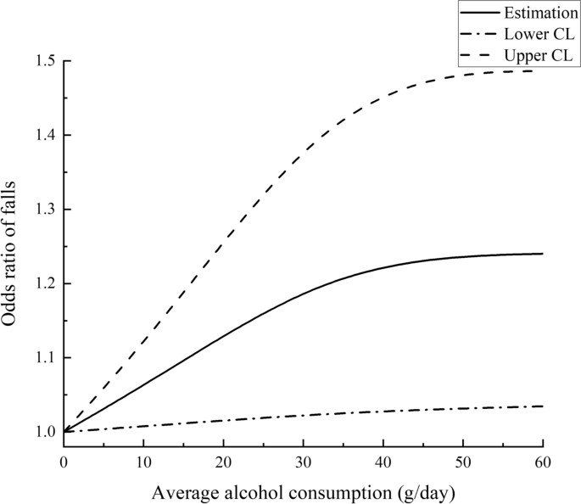

Age.

- Alcohol consumption and its link to falls is dependent on age, most prevalent among the 20-24 age group (Woods, Jones, and Usher, 2019).

- Alcohol is a strong indicator of falls among the elderly (Grundstrom, Guse and Layde, 2012; Chang and Do, 2015).

- Younger populations (20-29 years) are more prone to alcohol-related falls (Hides et al., 2014).

- Alcohol has been linked to fall-related emergency visits in populations aged over 65 (Shakya et al., 2020).

- Emergency department visits indicating alcohol usage decreases with advancing age; 4.1% for 65-75 years, 1.5% for 75-84 years and <1% for 85+ years (Shakya et al., 2020).

- The population aged 65 and over is more prone to falls due to the dose-effect relationship and reduced metabolic activities in the body due to chronic exposure and age (Woods, Jones, and Usher, 2019).

- For the working-age population (15-64 years) visiting emergency departments, fall-related injuries were twice as likely associated with alcohol use (adjusted odds ratio of 2.3) (Akshaya and Aldhaleei, 2024).

- Older population is more prone to falls but not specifically linked to alcohol (Woods, Jones, and Usher, 2019).

Figure 2: Comparison of alcohol and non-alcohol-related fall presentations by age group (Woods, Jones, and Usher, 2019).

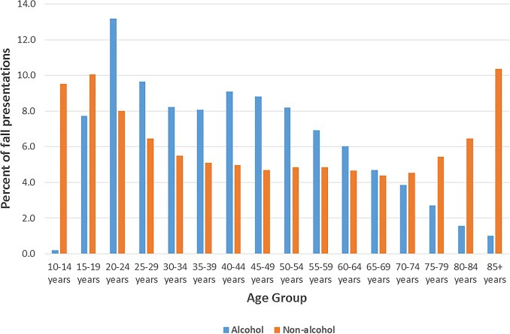

Gender.

- Association between alcohol falls among the elderly and gender-specific risk factors (Chang and Do, 2015).

- Gender should be considered when planning fall prevention strategies, as there are differences in aggravating and protective factors of falls among genders (Chang and Do, 2015).

- Falls among men visiting the emergency department (3.8%) were more likely to be associated with alcohol than women (1.0%) (Bye, Bogstrand and Rossow, 2021; Yuan et al., 2023).

- Even when alcohol consumption is the same, biological differences in genders lead to different outcomes of alcohol consumption. This leads to an increase in fall risk in women as compared to men after a set number of drinks (Cherpitel et al., 2014)

- Elderly women are more likely to be injured during alcohol falls due to other factors such as menopause and lifestyle factors (Gale, Cooper and Aihie Sayer, 2016).

Ethnicity.

- There exists some studies of the alcohol consumption of different ethnicities and hospital admission for general and alcohol-related falls. The link between alcohol falls and ethnicity is not established (Hurcombe, Bayley and Goodman, 2010).

- Analysing the alcohol consumption between different ethnicities may provide a view into the fall risk. Given the premise of alcohol consumption’s link to increased fall risk is accepted.

- While White British groups have a higher alcohol consumption in the UK compared to ethnic minorities, alcohol consumption varies due to culture, religion, and many other factors (Institute of Alcohol Studies, 2020).

Deprivation.

- Alcohol is one of the main contributors to social and health inequalities. Individuals from the lowest socioeconomic class were found to be twice as likely to experience death either partly or entirely because of alcohol use compared to those in higher socioeconomic groups (Institute of Alcohol Studies, 2020; Jones et al., 2015).

- Adults living in the least deprived areas were more likely to drink over 14 units of alcohol in a usual week than those living in the most deprived areas (27% compared with 18%) (GOV.UK, 2021).

- The association between socioeconomic status and alcohol consumption is an understudied area. Therefore, linking alcohol consumption to falls since the link between alcohol consumption and falls is not concrete. People in higher socio-economic classes tend to drink more than those in lower socio-economic classes however, the latter group appears to be more affected by harmful alcohol-related outcomes such as falls and injuries (Collins, 2016).

The main recommendations put forward by the above papers include:

- The use of validated and reliable tools to measure alcohol intake rather than the average consumption. Alcohol consumption at the time of fall may provide a clear link between alcohol consumption and fall.

- The type of link between alcohol and falls should be clarified in studies. The dose-dependent link between alcohol consumption and falls in acute intoxication and the link between cumulative and chronic alcohol exposure and falls.

- Areas of moderate alcohol consumption and falls should be thoroughly researched, due to prevalent studies showing a decreased risk of falls. Hence, making the current alcohol consumption recommendations potentially beneficial to reducing fall risks.

- There should be specific research linking and showing the relationship between alcohol-related falls and age, gender, ethnicity, and socioeconomic status.

- Data gained from these studies could be used to improve fall prevention programmes. The lack of specific data linking alcohol falls and the factors mentioned above do not allow for specific interventions tailored to specific age groups, gender, socioeconomic class, or ethnicity.

Injuries in alcohol-related falls.

- Advancing age strongly predicts the type and severity of injuries sustained during falls (Chatha et al., 2017; Ambrose, Cruz, and Paul, 2015).

- The severity of the injuries sustained can be based on the alcohol consumption as well as the location of drinking (Ye et al., 2020).

- Alcohol-related falls are linked to age, gender and type of injury sustained (Woods, Jones, and Usher, 2019).

Figure 3: Comparison of alcohol and non-alcohol-related fall presentations by body region injured. (Woods, Jones, and Usher, 2019).

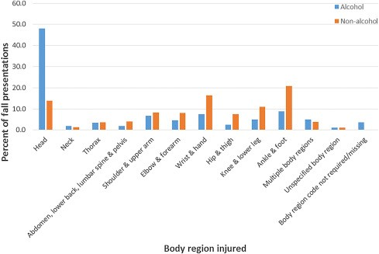

Pelvic and hip fractures.

- 95% of hip fractures are linked to falls in the elderly and polytrauma is more common (NICE, 2019).

- Fractures come with complications such as delirium and deep vein thromboembolism. These complications lead to further interventions and prolonged hospital stays (Ambrose, Cruz, and Paul, 2015).

Head injuries.

Figure 4: Primary part of the body part injured in fall emergency department visits and whether alcohol is indicated (Shakya et al., 2020).

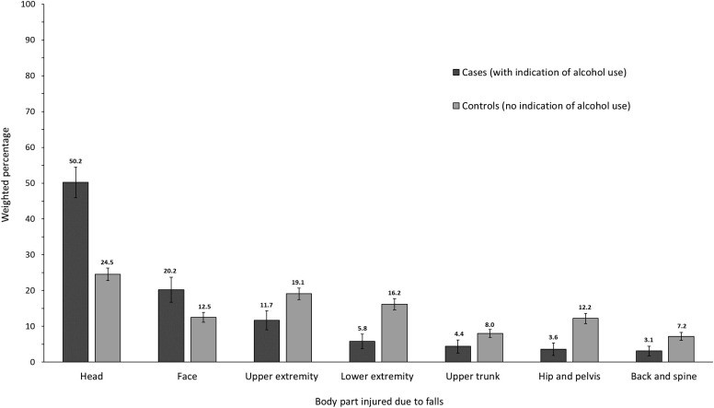
- More head injuries in alcohol-related ED visits (34.8%) as compared to non-alcohol-related emergency department visits (17%). (Shakya et al., 2020; Yuan et al., 2023, Kim et al., 2021).

- Alcohol intoxication is a strong predictor of traumatic brain injury (TBI) and a substantial proportion of TBIs occur in intoxicated individuals, up to 30%. (Weil, Corrigan and Karelina, 2018; Friedland, Brunton and Potts, 2013).

- Compared to sober patients, alcohol-intoxicated patients are likely to have head injuries due to falls (Chatha et al., 2017).

Hospitalisations.

- More hospitalisations due to the severity of alcohol-related falls as compared to non-alcohol-related falls (Shakya et al., 2020).

- Alcohol misuse is also linked to an increased risk of osteoporosis and fragility fractures (Stevens, 2005; Bye, Bogstrand and Rossow, 2021).

- Alcohol-related injury patients spend more time hospitalised than non-alcohol-related injury patients (Shakya et al., 2020).

The main recommendations put forward by the above papers include:

- Understanding the link between different factors and falls may be beneficial to reducing the number and severity of alcohol-related injuries.

- The recommendations for the use of supplements in elderly ladies to reduce the severity of injuries sustained in falls.

- Diverting alcohol-related injuries from other injuries in EDs due to the severity of these injuries may be a viable option.

Costs of alcohol-related injuries.

- Alcohol and alcohol falls cost society in numerous ways such as the cost to the healthcare system, cost to the justice system, economic costs due to loss of productivity and cost to social services
(Grundstrom, Guse and Layde, 2012; Ambrose, Cruz, and Paul, 2015).

- Alcohol-related incidents reported cost the NHS an estimated £3.5 billion a year, accounting for 3.6% of its annual budget. The yearly cost of alcohol to society is estimated to be £21 billion (UK Parliament, 2023; Arnett and Robineau, 2017).

- Alcohol-related incidents accounted for 37% of ambulance time, more than 5% of hospital admissions and 25% of emergency department work. Compared to Scotland which had the lowest rate of alcohol-related hospital admissions in 25 years after implementing its controversial minimum unit pricing (MUP) for alcohol to reduce alcohol intake (Boyd, 2023).

- Alcohol Intoxication Management Services (AIMS) was implemented to reduce the strain of alcohol use on the NHS. It aimed to divert and manage alcohol related from EDs by using Drunk Tanks, Safe Havens, and Alcohol Treatment Centres (ATCs). However, there is no formal evaluation of the effectiveness of this program. (Irving et al., 2017).

- The National Drug Treatment Monitoring System (NDTMS) shows a predominantly white population in treatment for alcohol use (about 93% in 2018/2019) in England (Institute of Alcohol Studies, 2020).

- The number of people in treatment for alcohol, the median age of 46 years, decreased from 2013/2014 at 17% to its lowest in 2017/2018 at 6% (Public Health England, 2018).

- Alcohol treatment services are underutilised by people from Black and Minority Ethnic (BME) backgrounds. (Gleeson et al., 2019).

- There exist barriers that prevent people from minority ethnic backgrounds from accessing and using these alcohol treatment services. These barriers can be religious, lack of trust in the confidentiality of the service, community shame and stigma (Gleeson et al., 2019).

The main recommendations put forward by the above papers include:

- Community-based approaches such as limiting marketing, taxing, and increasing social responsibility should be considered.

- Recent cuts to local and public health budgets mean prevention programs should be made sustainable to reap the benefits of these intervention programmes.

- Interventions should also take into context the cultural context of alcohol consumption while looking at the data to address the most affected group of alcohol-related falls.

- Reasons for not engaging in intervention programs differ between and within communities. Intervention programs should be specific and target a particular group.

- The definitions of ethnic groups are too broad and make it difficult to explore real minority groups to assess the reasons for drinking, tailoring a specific intervention for that group and barriers against accessing the intervention.

References.

Akshaya S, B and Aldhaleei, W.A. (2024). Alcohol and Substance Use Among the Working Age Population: A Nationwide Study of Fall-Related Emergency Department Visits. Journal of Studies on Alcohol and Drugs, 85(3), pp.330–338. Available at: https://doi.org/10.15288/jsad.23-00330.
Ambrose, A.F., Cruz, L. and Paul, G. (2015). Falls and Fractures: A systematic approach to screening and prevention. Maturitas, 82(1), pp.85–93. Available at: https://doi.org/10.1016/j.maturitas.2015.06.035.
Angus, C. (2019). A generation of hidden drinkers: What’s happening to the drinking of theover50s?[online] Available at: https://www.ias.org.uk/2019/01/25/ageneration-of-hidden-drinkers-whats-happening-to-the-drinking-of-the-over-50s/.
Arnett, G. and Robineau, D. (2017). Alcohol and the NHS - five key questions. [online] The Guardian. Available at:
https://www.theguardian.com/news/datablog/2016/jan/22/alcohol-and-the-nhsfive-key-questions.
Boyd, S. (2023). No half measures. [online] The British Medical Association is the trade union and professional body for doctors in the UK. Available at: https://www.bma.org.uk/news-and-opinion/no-half-measures.
Bye, E.K., Bogstrand, S.T. and Rossow, I. (2021). The importance of alcohol in elderly’s hospital admissions for fall injuries: a population case-control study. Nordic Studies on Alcohol and Drugs, 39(1), pp.38–49. Available at: https://doi.org/10.1177/14550725211015836.
Chang, V.C. and Do, M.T. (2015). Risk Factors for Falls Among Seniors: Implications of Gender. American Journal of Epidemiology, 181(7), pp.521–531. Available at: https://doi.org/10.1093/aje/kwu268.
Chatha, H., Sammy, I., Hickey, M., Sattout, A. and Hollingsworth, J. (2017). Falling down a flight of stairs: The impact of age and intoxication on injury pattern and severity. Trauma, 20(3), pp.169–174. Available at: https://doi.org/10.1177/1460408617720948.
Cherpitel, C.J., Ye, Y., Bond, J., Borges, G. and Monteiro, M. (2014). Relative risk of injury from acute alcohol consumption: modeling the dose-response relationship in emergency department data from 18 countries. Addiction, 110(2), pp.279–288.
Available at: https://doi.org/10.1111/add.12755.
Close, J.C.T. (2003). Predictors of falls in a high-risk population: results from the prevention of falls in the elderly trial (PROFET). Emergency Medicine Journal, 20(5), pp.421–425. Available at: https://doi.org/10.1136/emj.20.5.421.
Collins, S. (2016). Associations Between Socioeconomic Factors and Alcohol Outcomes. Alcohol research : current reviews, [online] 38(1), pp.83–94. Available at: https://www.ncbi.nlm.nih.gov/pmc/articles/PMC4872618/.
Friedland, D., Brunton, I. and Potts, J. (2013). Falls and Traumatic Brain Injury in Adults Under the Age of Sixty. Journal of Community Health, 39(1), pp.148–150.
Available at: https://doi.org/10.1007/s10900-013-9752-3.
Gale, C.R., Cooper, C. and Aihie Sayer, A. (2016). Prevalence and risk factors for falls in older men and women: The English Longitudinal Study of Ageing. Age and Ageing, [online] 45(6), pp.789–794. Available at: https://doi.org/10.1093/ageing/afw129.
Gleeson, H., Thom, B., Bayley, M. and McQuarrie, T. (2019). Rapid evidence reviews:
Drinking problems and interventions in black and minority ethnic communities. [online] AlcoholChangeUK. Available at: https://alcoholchange.org.uk/publication/rapidevidence-review-drinking-problems-and-interventions-in-black-and-minority-ethniccommunities.
Goldberg, E.M., Babu, K.M. and Merchant, R.C. (2023). Alcohol-Related Falls Are
Increasing in Older Emergency Department Patients: A Call to Action. Annals of Emergency Medicine, 82(6). Available at:
https://doi.org/10.1016/j.annemergmed.2023.07.011.
GOV.UK (2021). Chapter 12: Alcohol. [online] GOV.UK. Available at:
https://www.gov.uk/government/publications/delivering-better-oral-health-anevidence-based-toolkit-for-prevention/chapter-12-alcohol.
Grundstrom, A.C., Guse, C.E. and Layde, P.M. (2012). Risk factors for falls and fall related injuries in adults 85 years of age and older. Archives of Gerontology and Geriatrics, 54(3), pp.421–428. Available at: https://doi.org/10.1016/j.archger.2011.06.008.
Hides, L., Limbong, J., Vallmuur, K., Barker, R., Daglish, M. and Young, R.M. (2014). Alcohol-related emergency department injury presentations in Queensland adolescents and young adults over a 13-year period. Drug and Alcohol Review, 34(2), pp.177–184. Available at: https://doi.org/10.1111/dar.12218.
Hurcombe, R., Bayley, M. and Goodman, A. (2010). Ethnicity and alcohol: a review of the UK literature. [online] ResearchGate. Available at:
https://www.researchgate.net/publication/277771934_Ethnicity_and_alcohol_a_revi ew_of_the_UK_literature [Accessed 5 Oct. 2024].
Institute of Alcohol Studies (2020). Ethnic minorities and alcohol. [online] Institute of Alcohol Studies. Available at: https://www.ias.org.uk/report/ethnic-minorities-andalcohol/.
Irving, A., Goodacre, S., Blake, J., Allen, D. and Moore, S.C. (2017). Managing alcohol related attendances in emergency care: can diversion to bespoke services lessen the burden? Emergency Medicine Journal, [online] 35(2), pp.79–82. Available at: https://doi.org/10.1136/emermed-2016-206451.
Jones, L., Bates, G., McCoy, E. and Bellis, M.A. (2015). Relationship between alcohol attributable disease and socioeconomic status, and the role of alcohol consumption in this relationship: a systematic review and meta-analysis. BMC Public Health, [online] 15(1). Available at: https://doi.org/10.1186/s12889-015-1720-7.
Kim, S.H., Kim, S., Cho, G.C., Lee, J.H., Park, E.J. and Lee, D.H. (2021). Characteristics of fall-related head injury versus non-head injury in the older adults. BMC Geriatrics, 21(1). Available at: https://doi.org/10.1186/s12877-021-02139-4.
Kool, B., Ameratunga, S. and Jackson, R. (2009). The role of alcohol in unintentional falls among young and middle-aged adults: a systematic review of epidemiological studies. Injury Prevention, 15(5), pp.341–347. Available at: https://doi.org/10.1136/ip.2008.021303.
Kool, B., Ameratunga, S., Robinson, E., Crengle, S. and Jackson, R. (2008). The contribution of alcohol to falls at home among working-aged adults. Alcohol, 42(5), pp.383–388. Available at: https://doi.org/10.1016/j.alcohol.2008.04.004.
Mukamal, K.J., Mittleman, M.A., Longstreth, W.T., Newman, A.B., Fried, L.P. and
Siscovick, D.S. (2004). Self-Reported Alcohol Consumption and Falls in Older Adults:
Cross-Sectional and Longitudinal Analyses of the Cardiovascular Health Study.
Journal of the American Geriatrics Society, 52(7), pp.1174–1179. Available at: https://doi.org/10.1111/j.1532-5415.2004.52318.x.
NICE (2019). CKS is only available in the UK. [online] NICE. Available at:
https://cks.nice.org.uk/topics/falls-risk-assessment/backgroundinformation/complications/.
Public Health England (2018). Alcohol and drug treatment for adults: statistics summary 2017 to 2018. [online] GOV.UK. Available at:
https://www.gov.uk/government/statistics/substance-misuse-treatment-for-adultsstatistics-2017-to-2018/alcohol-and-drug-treatment-for-adults-statistics-summary2017-to-2018.
Qian, X.X., Chau, P.H., Kwan, C.W., Lou, V.W.Q., Leung, A.Y.M., Ho, M., Fong, D.Y.T. and Chi, I. (2020). Investigating Risk Factors for Falls Among Community-Dwelling Older Adults According to Who’s Risk Factor Model for Falls. The journal of nutrition, health & aging, 25(4). Available at: https://doi.org/10.1007/s12603-020-1539-5.
Shakya, I., Bergen, G., Haddad, Y.K., Kakara, R. and Moreland, B.L. (2020). Fall-related emergency department visits involving alcohol among older adults. Journal of Safety Research, 74. Available at: https://doi.org/10.1016/j.jsr.2020.06.001.
Stevens, J.A. (2005). Gender differences for non-fatal unintentional fall related injuries among older adults. Injury Prevention, 11(2), pp.115–119. Available at: https://doi.org/10.1136/ip.2004.005835.
Stewart, C. (2022). Alcohol units consumed in England by gender & age 2019. [online] Statista. Available at: https://www.statista.com/statistics/369808/alcohol-unitsconsumed-by-gender-and-age-in-england/.
Sun, Y., Zhang, B., Yao, Q., Ma, Y., Lin, Y., Xu, M., Hu, M., Hao, J., Jiang, M., Qiu, C. and Zhu, C. (2022). Association between usual alcohol consumption and risk of falls in middle-aged and older Chinese adults. BMC Geriatrics, 22(1). Available at: https://doi.org/10.1186/s12877-022-03429-1.
Tan, G.J., Tan, M.P., Luben, R.N., Wareham, N.J., Khaw, K. and Myint, P.K. (2021). The relationship between alcohol intake and falls hospitalization: Results from the EPICNorfolk. Geriatrics & Gerontology International, [online] 21(8), pp.657–663. Available at: https://doi.org/10.1111/ggi.14219.
Taylor, B., Irving, H.M., Kanteres, F., Room, R., Borges, G., Cherpitel, C., Greenfield, T. and Rehm, J. (2010). The more you drink, the harder you fall: A systematic review and meta-analysis of how acute alcohol consumption and injury or collision risk increase together. Drug and Alcohol Dependence, 110(1-2), pp.108–116. Available at: https://doi.org/10.1016/j.drugalcdep.2010.02.011.
UK Parliament (2023). Alcohol treatment services - Committees - UK Parliament. [online] Parliament.uk. Available at: https://committees.parliament.uk/work/7257/alcoholtreatment-services/.
Weil, Z.M., Corrigan, J.D. and Karelina, K. (2018). Alcohol Use Disorder and Traumatic Brain Injury. Alcohol research : current reviews, [online] 39(2), pp.171–180. Available at: https://www.ncbi.nlm.nih.gov/pmc/articles/PMC6561403/#:~:text=Alcohol%20into xication%20is%20one%20of.
Wong, H., Heuberger, R., Logomarsino, J. and Hewlings, S. (2016). Associations between alcohol use, polypharmacy and falls in older adults. Nursing Older People, [online] 28(1), pp.30–36. Available at: https://doi.org/10.7748/nop.28.1.30.s22.
Woods, C., Jones, R. and Usher, K. (2019). The impact of unintentional alcohol related falls on emergency departments. Australasian Emergency Care, 22(1), pp.22–
27. Available at: https://doi.org/10.1016/j.auec.2018.11.001.
Ye, Y., Cherpitel, C.J., Witbrodt, J., Andreuccetti, G. and Room, R. (2020). The interactive effect of location, alcohol consumption and non-traffic injury. Addiction, 115(9), pp.1640–1649. Available at: https://doi.org/10.1111/add.14992.
Yuan, K., Haddad, Y., Law, R., Shakya, I., Haileyesus, T., Navon, L., Zhang, L., Liu, Y. and Bergen, G. (2023). Emergency Department Visits for Alcohol-Associated Falls
Among Older Adults in the United States, 2011 to 2020. Annals of Emergency Medicine, [online] 82(6), pp.666–677. Available at:
https://doi.org/10.1016/j.annemergmed.2023.04.013.

